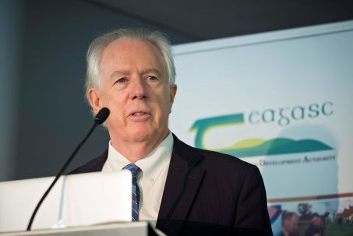

Banning Garrett is a Washington-based strategic thinker, writer, keynote speaker, and entrepreneur with more than four decades of experience in national security, US-China relations, and global trends.
He currently focuses on exponential technologies and their impact on the economy and intersection with long-term global trends, urbanization, development, and geopolitics.
Garrett has consulted to the World Bank, the United Nations, and the US government, and has written for more than two dozen journals and media outlets and has been interviewed by numerous international broadcast and print media.
Garrett is on the faculty of Singularity University, a Senior Fellow at the Global Federation of Competitiveness Councils, a Senior Fellow at Global Urban Development, and a consultant to the Institute for Defense Analysis. Garrett has made presentations to think tanks, business groups, international conferences, UN organizations, and governments in Asia, Africa, Latin America, Europe and North America.
Garrett was founding director of the Atlantic Council's Strategic Foresight Initiative and created and led the Council program on the implications of emerging technologies and its Urban World 2030 program. He was Director of the Council’s Asia Program (2003-2012) and in 2006 established and subsequently led the Council’s cooperation with the National Intelligence Council (NIC) in production of the NIC unclassified, quadrennial long-term global trends assessments. Garrett has also worked on US-China relations since the 1970s.
Besides writing and speaking about US-China relations, he consulted to the US Government and conducted an informal strategic dialogue between China and the US from 1981-2002 before joining the Atlantic Council. Garrett has a BA from Stanford and a PhD from Brandeis University.

