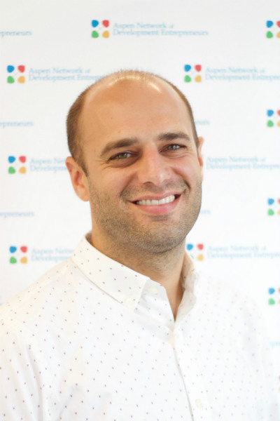

Matt Guttentag, Director, Research & Impact, Aspen Network of Development Entrepreneurs (ANDE)
Matt is ANDE’s Director of Research & Impact. Matt joined ANDE from LINC, where he served as a Program Director, leading action research programs to improve financial sustainability for civil society around the world. Prior to his time at LINC, Matt was the Partnership Advisor for the U.S. Global Development Lab (USAID) where he managed the Partnering to Accelerate Entrepreneurship (PACE) program, working directly with over 30 for- and non-profit partners to build and manage 12 public private partnerships connecting early-stage enterprises to over $100 million of private seed investment capital. Matt also led the development of the partnership to support the Global Accelerator Learning Initiative (GALI), working with the Lemelson Foundation, Omidyar Network, and Argidius Foundation to seed phase one of ANDE’s program.

