Laura Giadorou Koch
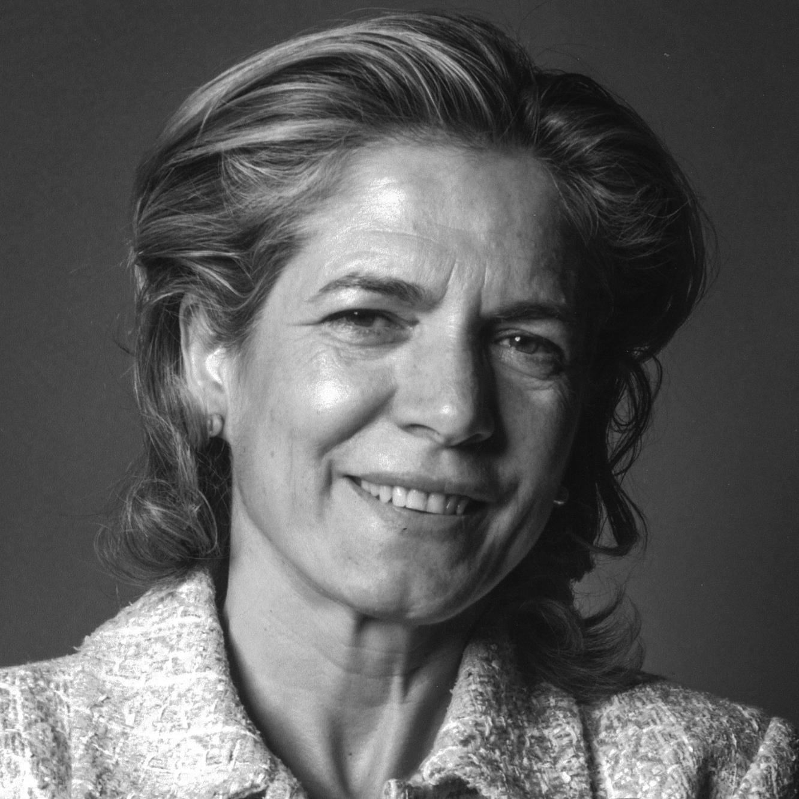

www.linkedin.com/in/lauragiadoroukoch

Laura Giadorou Koch, JD and LLM in NY and Argentina
CEO of Dolium Wines, a “B Certified Company” awarded in 2014, 2016 & 2018 “The Best for the World in Environment” by B Lab.
My life purpose is creating awareness and inspire people and companies as a force for good.
I serve as board members in several for profit and non-for-profit companies focused on advancing education on social and emotional intelligence skills. These include: Think Equal USA, Million Peacemakers, Nardagani, and Eye to Eye National and BUILD NY.
Also, currently serve as Ashoka Senior Advisor and gives talks on Microfinance, Social Entrepreneurship and “Using business as a force for good” at NYU, Columbia University, Fordham U, London Business School, Kiva U, Ashoka U. As well have given seminars and workshops at several public and private high schools in NY, CT and DC.
As well,
For YPO have volunteer as Chair for the Social Engagement Network, Social Impact Counsel Networks, and Helping Disadvantaged Kids Network.
Has published articles for the Wall Street Journal (op-ed), Real Leaders Magazine, Huffington Post, and several Argentine newspapers.
During the ‘80 and ‘90, Practiced corporate law at several Wall Street law firm for practically two decades specializing in cross-border transactions for Latin American and European clients.

