Dr. Michiharu Nakamura
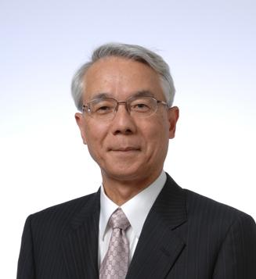
Dr. Nakamura graduated from the University of Tokyo and joined Hitachi Central Research Laboratory in 1967, where he was engaged in compound semiconductors and optoelectronics research. He is entitled an IEEE fellow and a JSAP fellow for his pioneering achievements in optoelectronics.
In 2004, he was appointed to Executive Vice President and Executive Officer of Hitachi Ltd. and then the Board of Directors. He was responsible for corporate technology development and new business incubation.
In 2011, he assumed the office of the President of Japan Science and Technology Agency, where policy-driven R&D funding is a major mission. After completing four-year presidency, he has been serving as the Counsellor to the President of JST.
He is currently serving as the Deputy Chairman of the Engineering Academy of Japan, a member of the Advisory Board for Promotion of Science and Technology Diplomacy and a member of the UN 10 Member Group supporting the Technology Facilitation Mechanism for STI for SDGs.

