Alfred Watkins

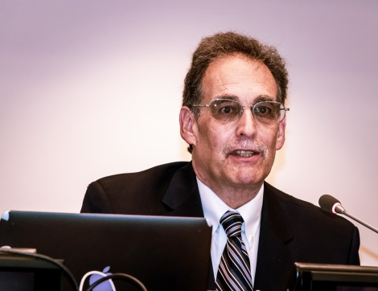

Alfred Watkins is Chairman of the Global Solutions Summit (GSS) which is dedicated to financing the large-scale deployment in emerging markets of commercially viable, financially-sustainable development solutions for potable water, renewable energy, ICT, health care, housing, sustainable agriculture and food processing. GSS 2018 convened at the United Nations in New York City on June 4, 2018 under the theme of “From Lab to the Last Mile: Technology Deployment Business Models for the SDGs.” GSS 2018 is the third in a series beginning with the Inaugural Summit at the US State Department in April 2014 and a Second Summit at the Clinton Presidential Library in December 2016.

Prior to founding the Global Solutions Summit, he worked for more than 23 years at the World Bank and served for more than six years as the World Bank’s Science and Technology Program Coordinator and head of the World Bank’s Science, Technology and Innovation Global Expert Team. He has extensive on-the-ground experience leading science, technology, and innovation capacity building programs and projects in Africa, Asia, and various countries in the Former Soviet Union. He organized two World Bank Global Forums on Science, Technology and Innovation Capacity Building for Sustainable Development (one in 2007 and another in 2009).

In March 2017, UN Secretary General António Guterres appointed him to a three-year term on the Governing Council of the Technology Bank for the Least Developed Countries (LDCs). The main objective of the Technology Bank, which was formally established by the UN General Assembly in December 2016, is to help LDCs identify and deploy the technology they need to (i) foster inclusive sustainable growth and (ii) achieve the SDGs.

