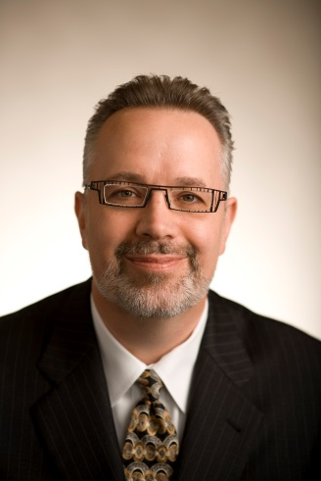

Dan Bena is Founder and CEO of Dan Bena, LLC, and an award-winning executive who served as PepsiCo’s Corporate Water Steward, and led the Sustainable Development agenda for PepsiCo Global Operations, using the power of the private sector as a force for good. He is Senior Advisor to Safe Water Network and serves or has served on the Leadership Group of the World Business Council for Sustainable Development (WBCSD); Steering Board of IFC’s 2030 Water Resources Group; Steering Committee of the United Nations CEO Mandate; the Global Agenda Council on Water Security of the World Economic Forum; and the Board of the International Society of Beverage Technologists. Bena completed a three-year term on the Board of the Washington-based US Water Alliance, and currently serves on the Board of the Creative Visions Foundation, a non-profit using media and the arts to develop agents of positive social change. Their signature program, called Rock Your World, engages middle and high school students in the UN Universal Declaration of Human Rights, and provides them the tools with which to become creative activists. Bena also serves on the Advisory Board of Artistic Circles, the Advisory Board of the Environmental Leader publications group, the America’s Water Initiative of the Earth Institute at Columbia University, and the new Elsevier journal, Water Security. Bena was selected as a mentor for the ThreeDotDash.org program of the We Are Family Foundation; a judge for the University of Notre Dame Corporate Adaptation Prize; an advisor to the social enterprise start-up, Keela, and an Advisory Board Member to the Conrad Foundation, host of the Conrad Innovation Challenge, using STEM to engage high school students across the globe to design solutions to the intractable challenges we face. He delivered the keynote address at the Royal Gala in the presence of TRH Princess Madeleine and Prince Daniel of Sweden, and has spoken at over 100 venues which span the business, government, academic, and non-profit worlds. He represented PepsiCo at theOur Food, Our Future Summit, in Dublin, Ireland, attended by the Prime Minister of Ireland and the Minister of Agriculture. He was invited to provide testimony to the US Senate, and keynoted the United Nations Youth Assembly to over 1,000 youth delegates from over 100 countries. Bena received theLight Up the Night Award from the Julia B. Andrus Foundation for youth advocacy and engagement, was honored to have October 24th proclaimed “Dan Bena Day” in New York State, and was recently named a “Global Goals Local Leader” by the UN Association for his role in the partnerships which have provided over 20 million people with access to safe water, thereby helping to advance the SDGs. Dan was invited by the President of the UN General Assembly to participate in a high-level panel on partnerships to advance the post-2015 Development agenda, and was named an Honorary Professor by Glasgow Caledonian University, and a Trustee of its New York College, which houses the transformative Fair Fashion Center. Dan has a BS in Biochemistry and an MS in Industrial Pharmacy. Keynote speaker, social media influencer, SDG advocate, and, above all, wife-, family-, and animal- lover. Learn more atwww.danbena.com.

