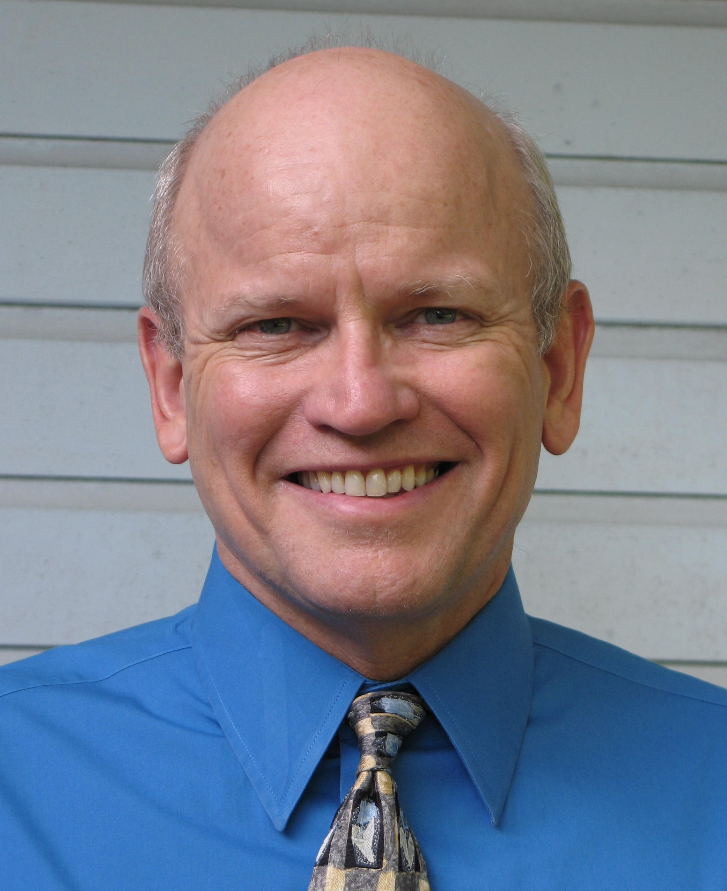

Fred T. Davies, Ph.D., CPH
Regents Professor Emeritus, Senior Borlaug Fellow Horticulture, Borlaug Institute of International Agriculture, Texas A&M University; Senior Fellow, Global Federation of Competitiveness Councils; former Senior Science Advisor and Jefferson Fellow, USAID; and past President, American Society for Horticultural Sciences; f-davies@tamu.edu

Dr. Fred Davies is a Regents Professor emeritus, Dept. of Horticultural Sciences, faculty of Molecular and Environmental Plant Sciences, and AgriLife Research Faculty Fellow at Texas A&M University. He is a Senior Borlaug Fellow in Horticulture at the TAMU Borlaug Institute of International Agriculture. In 2013-14, he was a Senior Science Advisor (Jefferson Science Fellow) at USAID, Bureau of Food Security / Office of Agricultural Research & Policy, Washington, D.C. He continues to advise USAID on food security, agriculture and horticulture - most recently serving as the team lead, evaluating USAID plant seed programs in West Africa. He has over 40 years’ experience in research, evaluation, teaching, industry outreach and consultancies in horticulture, agriculture, plant propagation and seed programs in more than 25 countries.

He received a B.A. and M.S. from Rutgers University, and a PhD in Horticultural Sciences, Plant Physiology and Tropical Agriculture from the University of Florida. He has been a Visiting Scientist at the USDA Horticultural Crops Laboratory (Oregon), CINVESTAV Plant Biology Institute (Mexico) and International Potato Center (Peru). He has also been a Visiting Professor at Oregon State University, Monterrey Tech. Univ. (Mexico), National Agrarian University of Peru, and Bogor Agricultural University [IPB (Indonesia)]. As an expert in international horticulture, agriculture and food security - he has been a Guggenheim Fellow and Senior Fulbright Fellow to Peru, Mexico, and Indonesia. He is past-president of American Society for Horticultural Sciences (ASHS) and International Plant Propagators Society (IPPS). He is a Fellow of the ASHS and IPPS. His research has been supported by NASA, National Science Foundation, U.S. Dept. of Agriculture, other agencies, and industry.

